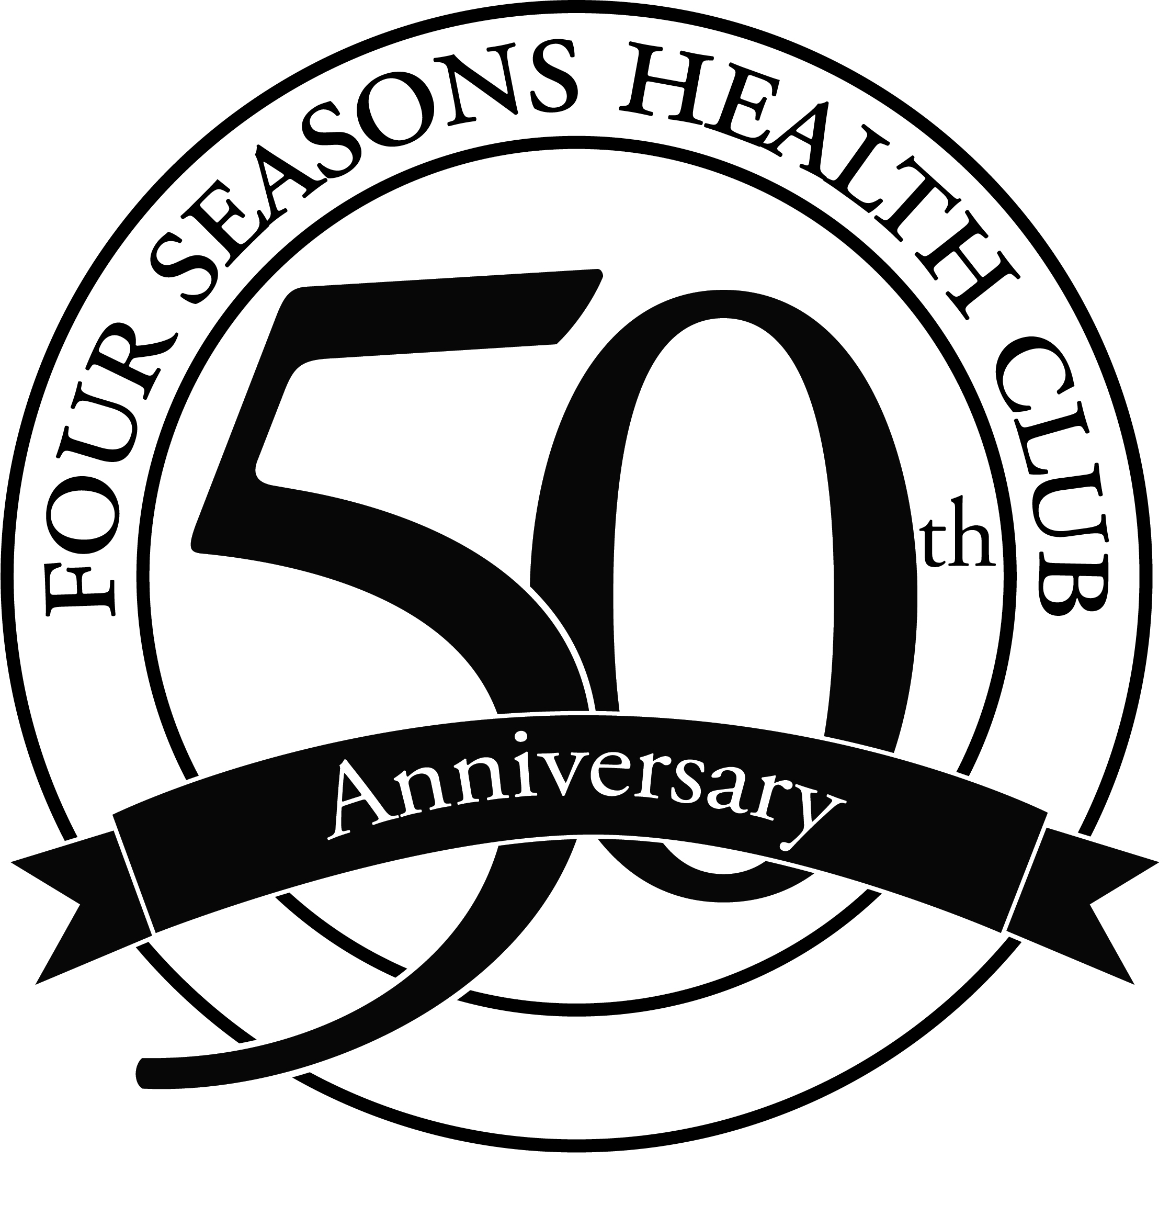
MEDIA CONTACT:
Stephanie Robertson
Marketing Coordinator
Stephanie@4seasons-club.com
309.663.2022 Ext. 134
FOUR SEASONS PROMOTES TWO TO EXECUTIVE AND MANAGEMENT TEAM
Four Seasons Health Club promotes internal applicants to fill Vice President of Business Solutions and Aquatics Manger positions.
BLOOMINGTON-NORMAL, Ill. (August 19, 2015) – Four Seasons Health Club promotes Cassandra Newman to Vice President of Business Solutions and Samantha Fleming to Aquatics Manager.
Four Seasons currently employs over 240 members of the community both part-time and full-time. The organization focuses on hiring individuals who can add to the culture and creates opportunities for advancement for these individuals to grow with the company. Four Seasons has leadership, management and executive teams which undergo Gallup Press’s Strengths Finder training. The training entails a series of group classes which teaches teams how to utilize their own strengths and their staff’s strengths to grow employees into positions they excel at and enjoy doing.
“At Four Seasons, we have made it a goal to place our employees in positions which they have strength, interest and opportunity to advance,” said CEO Jeff Leverton. “Our goal is to have employees who grow with our company. Cassandra and Samantha are great examples of employees who have shown us they are a culture fit and committed to the success of our organization and therefore have worked their way up to management and executive positions,” Leverton said.
Newman has 14 years of marketing, sales and business development experience. She has been promoted twice within Four Seasons Association since joining the team in 2013. Newman earned her bachelor’s degree in Integrated Marketing Communications from Abilene Christian University in 2004. As Vice President of Business Solutions, she oversees human resources, accounting, marketing and business development, and member relations.
Previously, Fleming spent over a year as the Administrative Support Specialist for Four Seasons. Prior to her work at the club, she also worked for the Normal Parks and Recreation Department. A graduate from Illinois State University, Fleming obtained a bachelor’s degree in Parks, Recreation and Leisure Facilities Management in 2014. Fleming will oversee all aquatic staff including lifeguards, swim coaches and swim instructors; she will take over pool scheduling, aquatic programs, swim lessons and more.
Four Seasons is currently hiring for several positions and is always accepting applications. Review open job listings and submit information at www.4seasons-club.com/about/employment.
--more--
About Four Seasons Health Club
Four Seasons Health Club is a not-for-profit fitness association with two locations in Bloomington, Ill. Since 1965, Four Seasons has offered a family oriented atmosphere that provides social, physical and recreational opportunities for our members. Four Seasons welcomes all members of McLean County in addition to offering discounted rates for Corporate Sponsors. For several years, we have been chosen by the community residents as the Pantagraph’s Readers’ Choice Best Fitness Center/Gym in Bloomington Normal, making it the club of choice in the community and to over 21,000 members. Four Seasons was also awarded the Illinois Healthy Worksite Silver Level award from 2015-2018. To learn more about Four Seasons Health Club visit www.4seasons-club.com or visit either location for a free tour and seven day trial during business hours.

