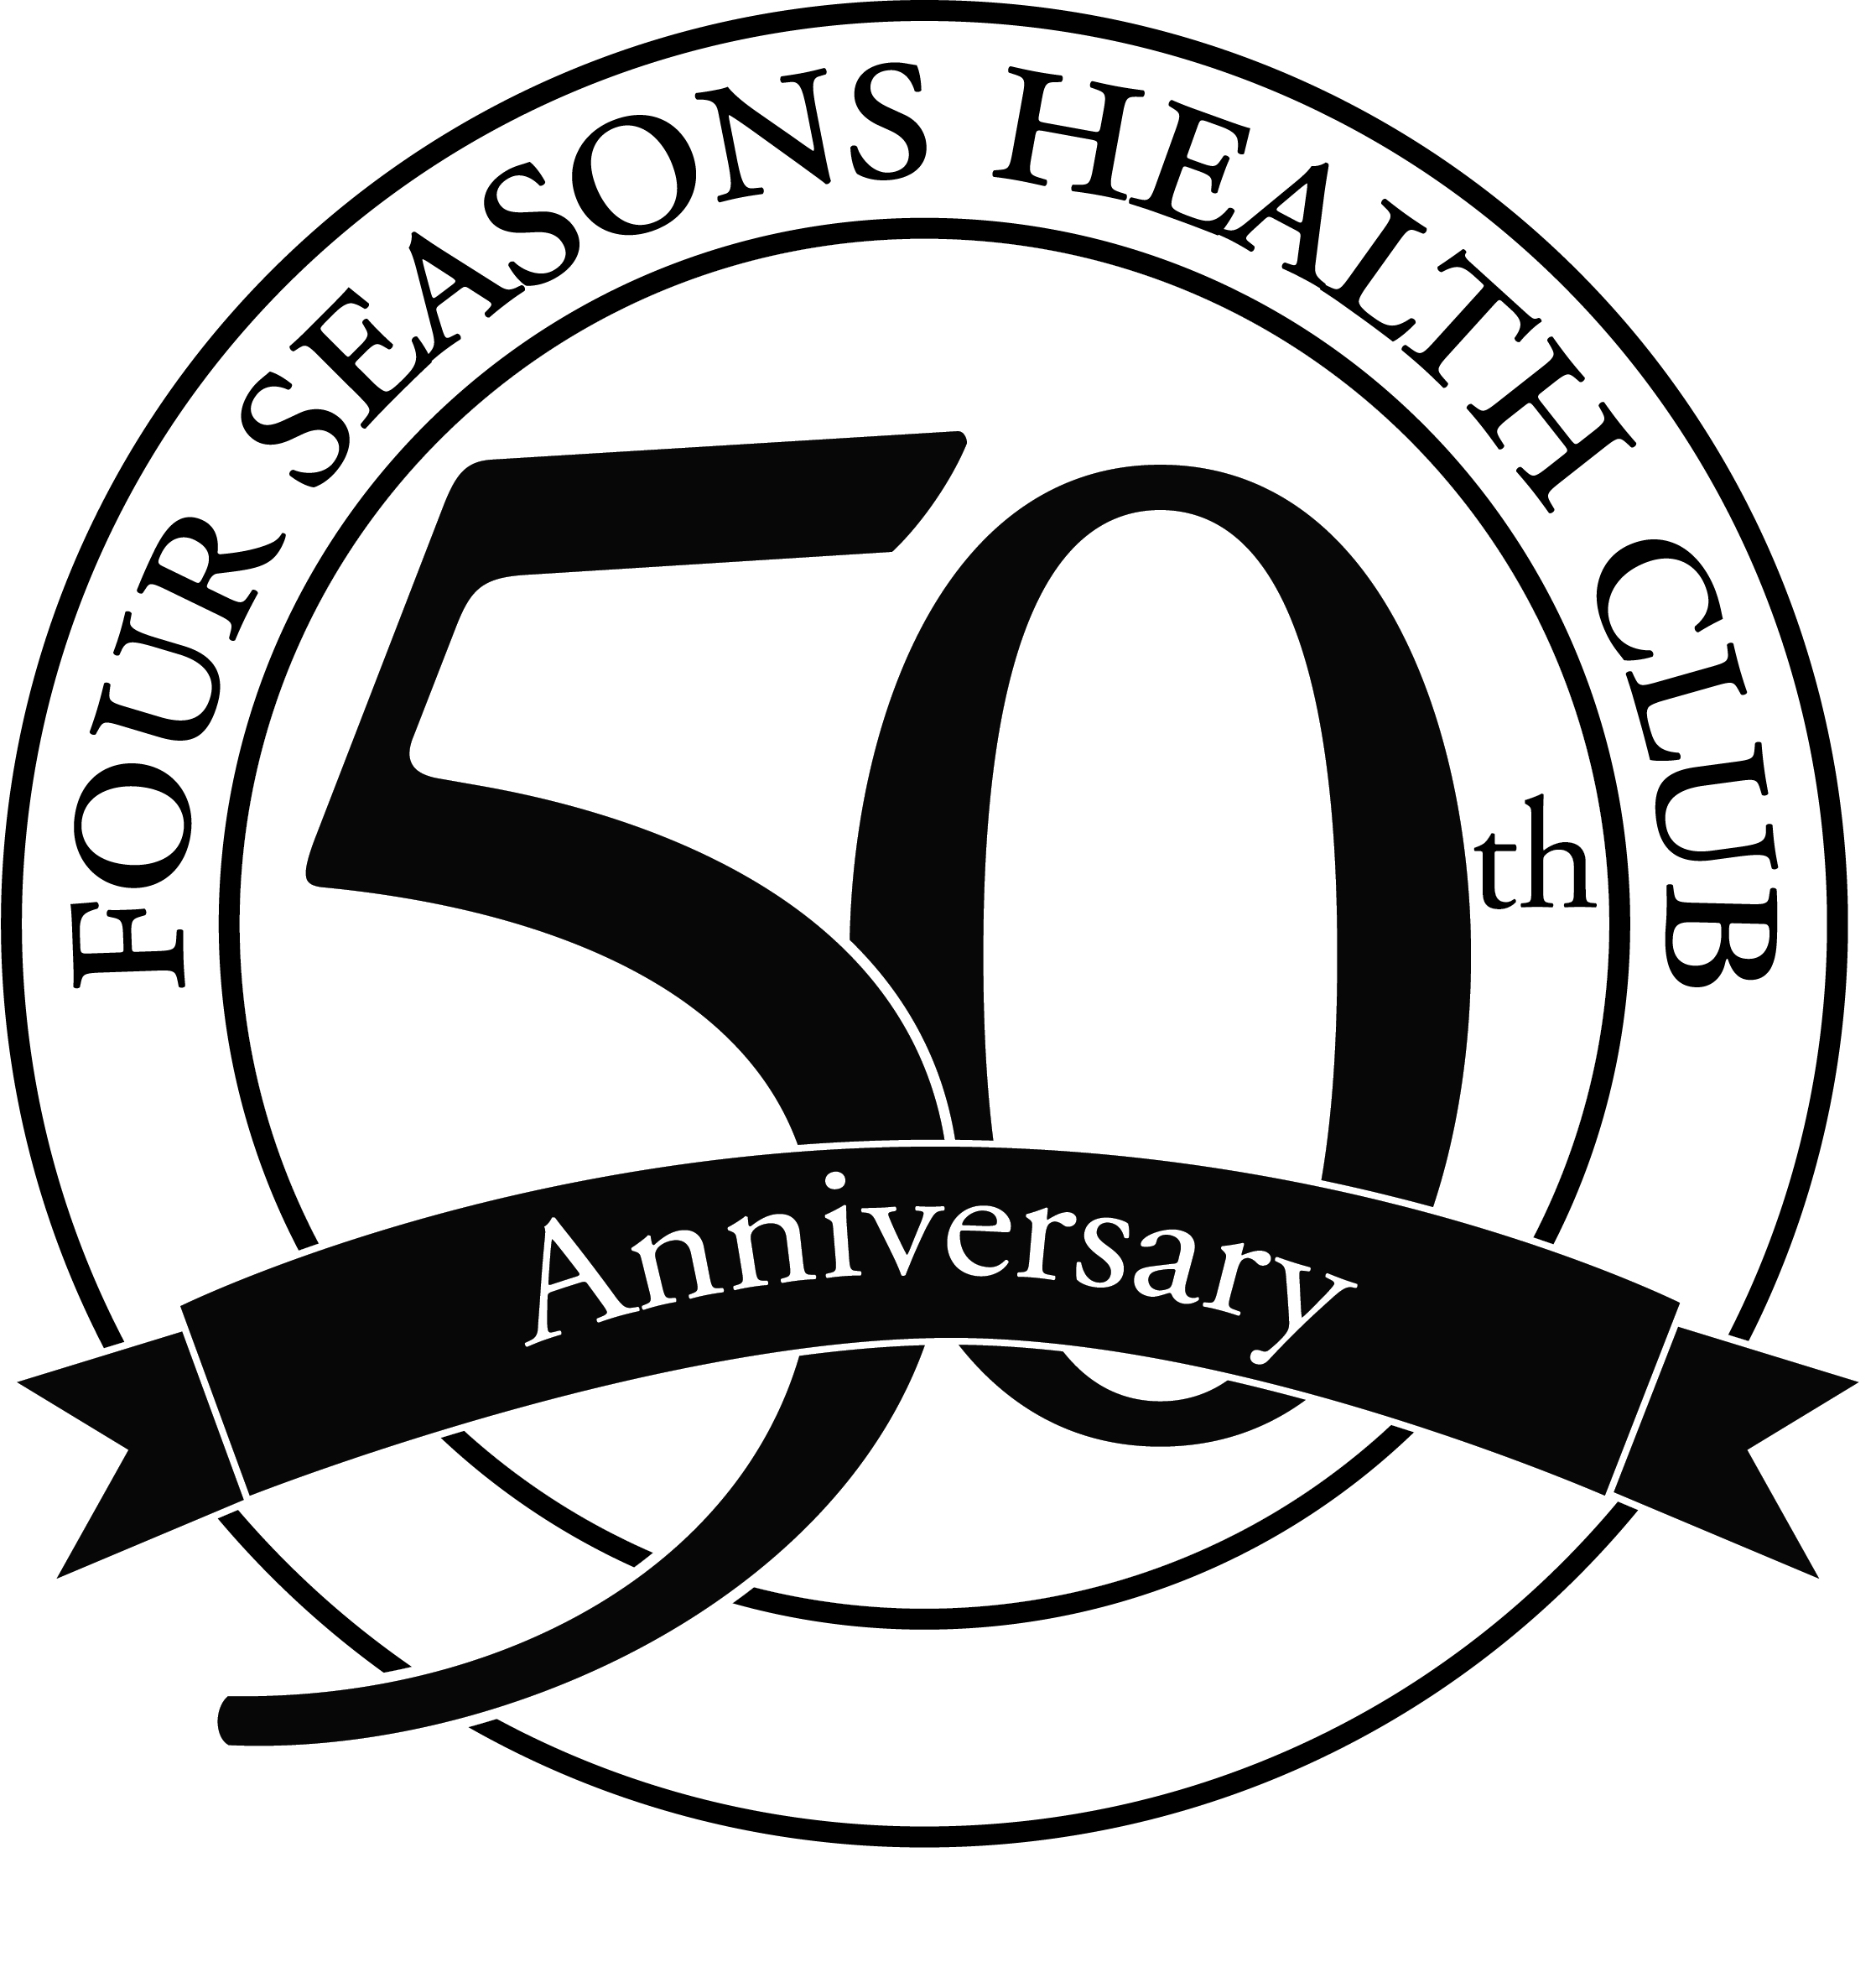**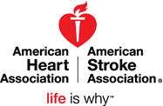MEDIA CONTACTS:**

Carrie Skogsberg, American Heart Association

(815) 988-6118; [carrie.skogsberg@heart.org](mailto:carrie.skogsberg@heart.org)

Stephanie Robertson, Four Seasons Health Club

(309) 663-2022 ext. 134; [stephanie@4seasons-club.com](mailto:stephanie@4seasons-club.com)

**FOR IMMEDIATE RELEASE**

**Four Seasons Health Club and American Heart Association to Recognize**

**Lifestyle Change Award Winners at McLean County Heart Walk**

**BLOOMINGTON-NORMAL, Ill. (July 21, 2015) –** Do you know someone who has made significant efforts to improve his or her heart health? The American Heart Association and local sponsor Four Seasons Health Club will showcase top nominees and recognize one individual as the Lifestyle Change Award winner at the McLean County Heart Walk on September 19 in Uptown Normal.

Individuals are encouraged to nominate friends, family members and coworkers who have implemented healthy behaviors such as quitting an unhealthy habit, exercising regularly or eating healthy to reduce risk factors for heart disease and stroke. The committee seeks stories with measurable results such as considerable weight loss, lowered blood pressure and controlled diabetes or cholesterol levels.

“Fitness is at the heart of what Four Seasons has provided Bloomington-Normal for 50 years,” said Four Seasons Vice President of Operations Catherine Porter. “This partnership allows us to join forces and together we can continue to build healthier lives in our community. We are proud to partner with the American Heart Association and excited to celebrate individuals who have made significant changes to lead a healthy lifestyle,” Porter said.

The American Heart Association strives to educate the public on the seven major risk factors of heart disease and stroke:

* Obesity
* Lack of physical activity
* Smoking
* Unhealthy eating habits
* Diabetes
* High cholesterol
* High blood pressure/hypertension

To submit a nomination for the Lifestyle Change Award, and to learn more about the McLean County Heart Walk, please visit [www.mcleancountyheartwalk.org](http://www.mcleancountyheartwalk.org) or www.4seasons-club.com /award.

**About the American Heart Association and American Stroke Association**

The American Heart Association and the American Stroke Association are devoted to saving people from heart disease and stroke – the two leading causes of death in the world. We team with millions of volunteers to fund innovative research, fight for stronger public health policies, and provide lifesaving

--more—

tools and information to prevent and treat these diseases. The Dallas-based American Heart Association is the nation’s oldest and largest voluntary organization dedicated to fighting heart disease and stroke. The American Stroke Association is a division of the American Heart Association. To learn more or to get involved, call 1-800-AHA-USA1, visit heart.org or call any of our offices around the country. Follow us on Facebook and Twitter.

**About Four Seasons Health Club**Four Seasons Health Club is a not-for-profit fitness association with two locations in Bloomington, Ill. Since 1965, Four Seasons has offered a family oriented atmosphere that provides social, physical and recreational opportunities for our members. Four Seasons welcomes all members of McLean County in addition to offering discounted rates for Corporate Sponsors. For several years, we have been chosen by the community residents as the Pantagraph’s Readers’ Choice Best Fitness Center/Gym in Bloomington-Normal, making it the club of choice in the community and to over 21,000 members. Four Seasons was also awarded the Illinois Healthy Worksite Silver Level award from 2015-2018. To learn more about Four Seasons Health Club visit www.4seasons-club.com or visit either location for a free tour and seven day trial during business hours.

###