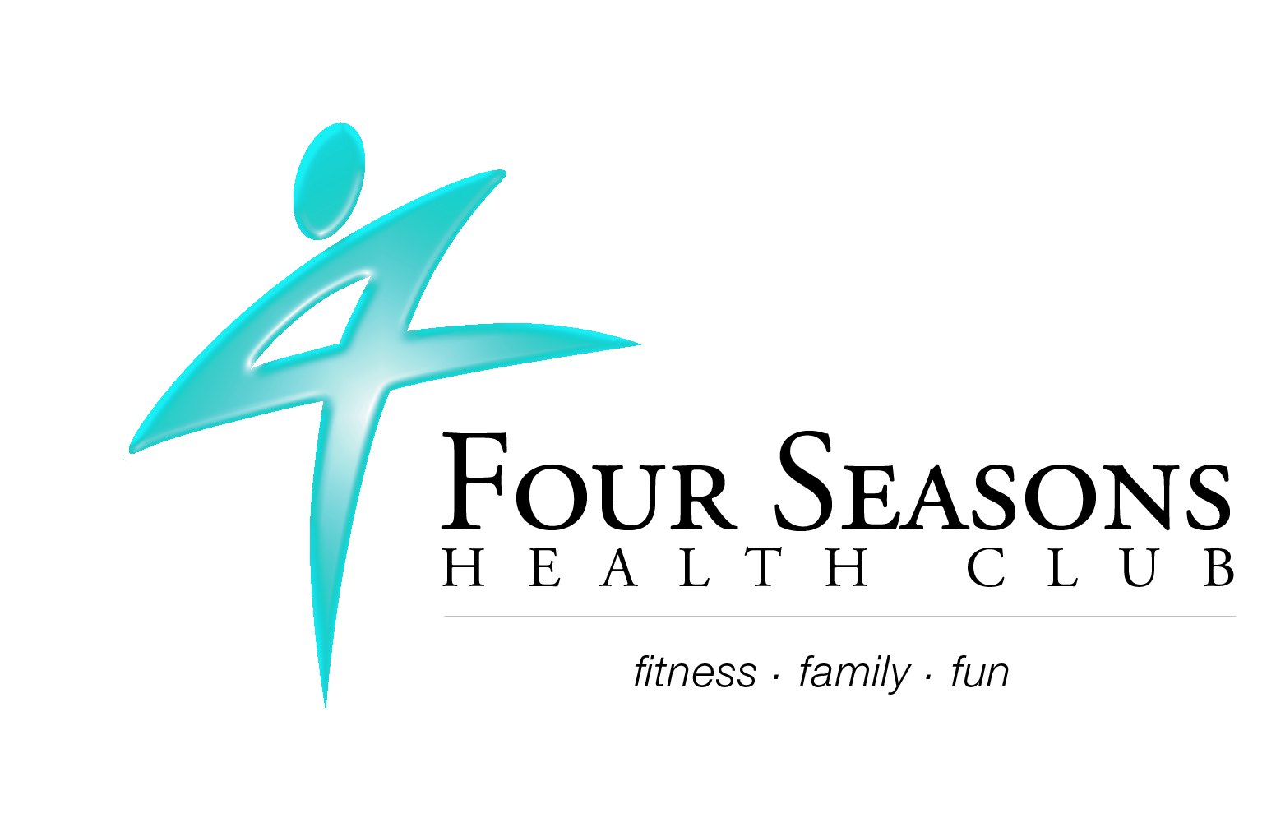
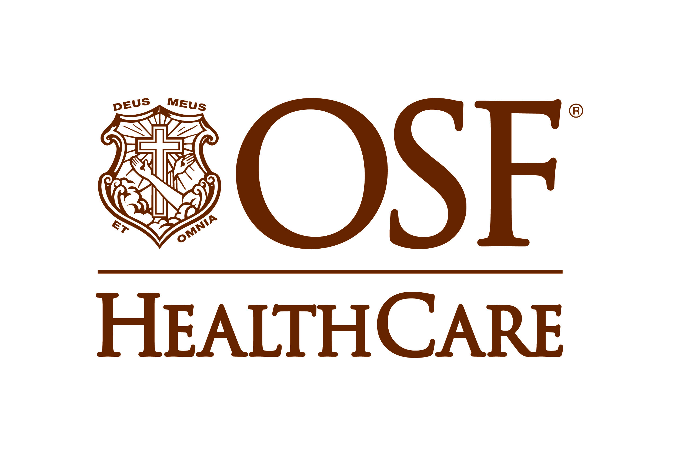

Catherine Porter, VP of Operations Valerie Hawkins, Marketing Specialist
Four Seasons Health Club OSF St. Joseph Medical Center
catherine@4seasons-club.com Valerie.f.hawkins@osfhealthcare.org
309-663-2022 ext. 235 309-665-5733

FOR IMMEDIATE RELEASE:

Four Seasons Health Club and OSF HealthCare partner to create Fit Together - a fitness program for seniors

Bloomington, IL – November 23, 2026– OSF HealthCare and Four Seasons Health Club are collaborating to create a unique opportunity for the older adult population in McLean County. This partnership will allow adults 65 and older who are patients of OSF HealthCare an opportunity to be referred to an exclusive Four Seasons senior fitness program called Fit Together.

Through the cooperative efforts of fitness professionals and primary care physicians, this program will guide participants to take an active role in their overall health, improve health statistics, and reduce hospital visits and readmissions through physical activity. It has been well-documented physical activity is essential in the prevention and treatment of diseases and should be regularly assessed and included in medical care.

“Four Seasons is very excited to become a strategic partner of OSF HealthCare physicians and offer Fit Together,” says Catherine Porter, Vice President of Operations, Four Seasons Health Club. “OSF physicians and Four Seasons exercise professionals will be working together to improve the overall health and well-being of senior patients by prescribing appropriate exercise modalities known to slow, stop, and reverse the progression of chronic diseases. Four Seasons has embodied fitness in Bloomington-Normal for 50 years, and we consider becoming part of the continuum of care as a new and additional opportunity to change lives in the community,” Porter continues.

The exclusive Fit Together monthly membership rate for patients 65 and older is $20 per person or $35 per couple. Participants gain access to both Four Seasons locations in Bloomington-Normal, which includes pools, hot tub, saunas, indoor track, and plenty of additional programming options.

OSF HealthCare patients wanting to participate in the program should consult their physician to receive a referral.

“Research shows regular physical activity can help improve the health and overall quality of life.” says Erin Kennedy, Director, Center for Healthy Lifestyles at OSF St. Joseph Medical Center. “Our goal of Fit Together is to introduce regular exercise and physical activity to our patients’ lives in order to improve their health and help them maintain their independence as they age.”

-30-

OSF St. Joseph Medical Center, located at 2200 E. Washington Street, Bloomington, Ill., is a 149-licensed bed, not for profit, acute care, and Level II Trauma Center facility, fully accredited by the Joint Commission. In 2014, the American Nurses Credentialing Center re-designated OSF St. Joseph Medical Center a Magnet hospital. OSF St. Joseph Medical Center is part of the OSF Healthcare System. In the spirit of Christ and the example of Francis of Assisi, the Mission of OSF HealthCare is to serve persons with the greatest care and love in a community that celebrates the Gift of Life. For more information about OSF St. Joseph Medical Center, please visit: www.osfstjoseph.org.

